GAMBIA….....DYH…..... SKILLCENTER.......PIRANG.....January..2022..…….NEWS

Dear Gambia friends,
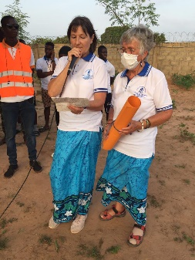
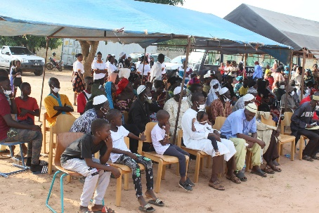
in August 2 years ago the property in Pirang was acquired. Since then, the property has been enclosed by hand, a shelter has been created, a well drilled, toilets built and a lot of planted food harvested.
This "oasis" celebrated its 2nd birthday in October. On this occasion, Nici and Anneliese from Germany visited, were able to present a donation from the Asarja community and celebrate the big anniversary on site.

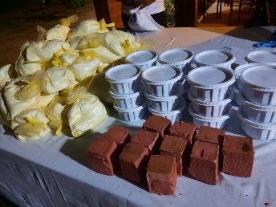
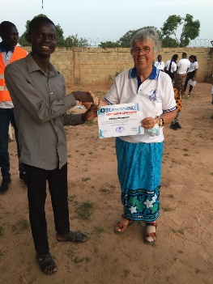
There were appreciative words and certificates for many committed people who have made DYH what it is to this day.
Self-produced soap and detergent were sold and it was demonstrated how T-shirts and bags are printed and fabric batik.

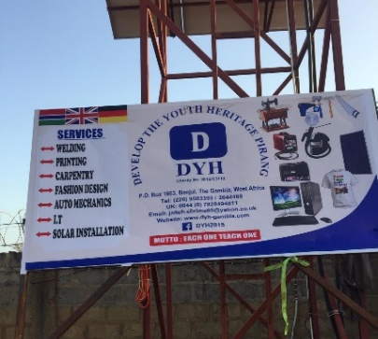

From now on, a large banner at the entrance represents what is hidden behind the name DYH and what DYH offers.

Unexpectedly and incomprehensibly, two young adults from DYH died in October. They were reliable and dedicated men who left a big gap. For Ebrima a great sadness and challenge not to lose courage. Reliable workers are sparsely sown in Gambia, so the loss of such members is all the more profound.

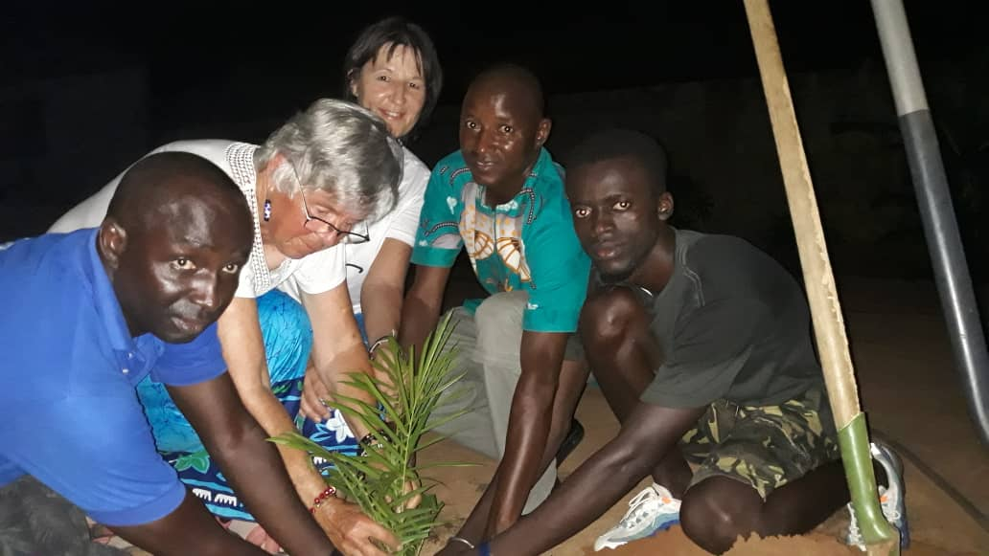

Sankung, one of the two, passed away while Anneliese and Nici were still in Gambia. In memory of him, they planted young palm trees at the center.

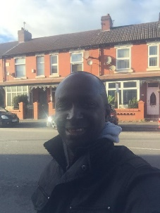
Ebrima Jaiteh travelled to the UK in November to renew his passport. The tense corona situation prompted him to return as soon as possible without visiting his partners in Germany, which everyone regretted very much.

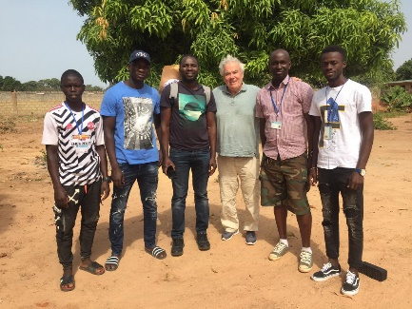
In December, Hannes Munz (from Winnenden) travelled to Gambia with friends and did not miss the opportunity to visit the DYH Center. He was very impressed by the work and vision of DYH. Many Gambians could benefit from it and it is worth supporting.

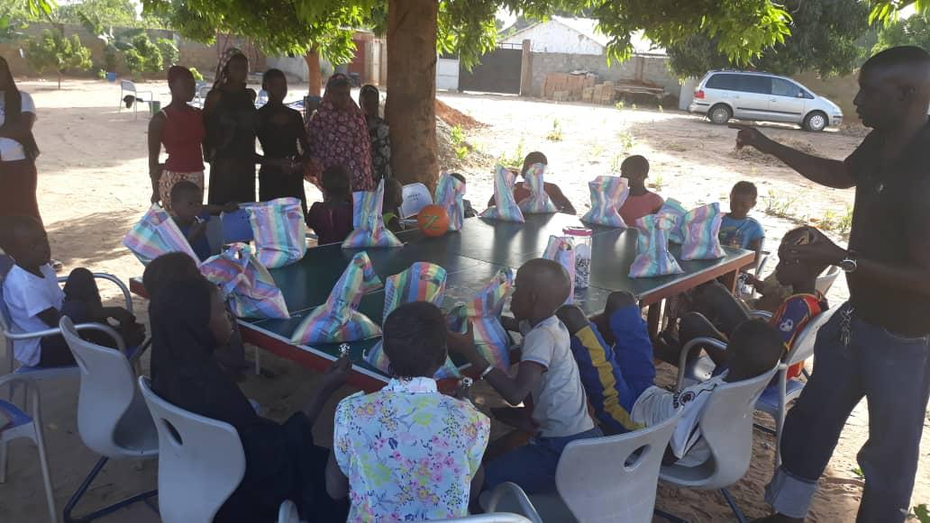
In Gambia, Muslims and Christians celebrate the festivals in respect of each other, including Christmas. Through a donation, there was even a gift: More than 50 children received a bag of rice, stationery and sweets, which triggered feelings of happiness.

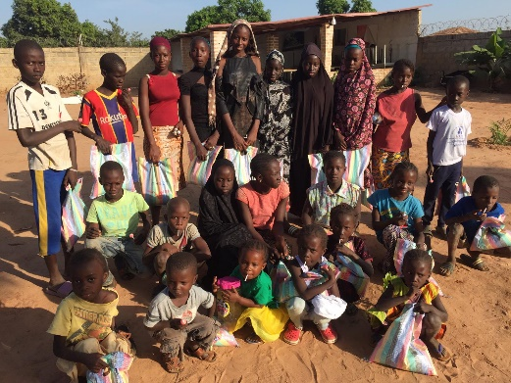

Thank you for all participating and accompanying DYH.
The expansion of electricity and the construction of a school building are pending.

Best regards (for the partners from Germany)
Dorothee

Donations for DYH are welcome to:
Ebrima Jaiteh, DYH,
IBAN: GB24MYMB23058026283884
BIC: MYMBGB2LXXX
www.dyh-gambia.com

